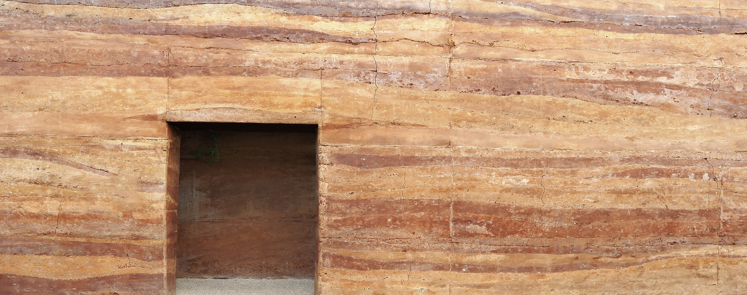

Rammed Earth Fact Sheet

Fact Sheet Rammed Earth Construction

Process for application of required permits, communication with Certifying Authority and services providers

Demolition Permit

Apply for building permit & for demolition removal work

1. .
2. .
3. .
4. .
5. .
6. .
7. .
8. .
9. .
10. .

Building Permit

1. .
2. .
3. .
4. .
5. .
6. .
7. .
8. .
9. .
10. .
11. .
12. .
13. .
14. .
15. .
16. .

Rammed Earth Fact Sheet

Fact Sheet Rammed Earth Construction

Procedures for recording the hire of plant and equipment

HIRE PLANT & EQUIPMENT PROCEDURE:

1. .
2. .
3. .
4. .
5. .
6. .

Rammed Earth Fact Sheet

Fact Sheet Rammed Earth Construction

OHS policies and procedures

Legislative Requirements

1. .
2. .
3. .
4. .
5. .
6. .

Company Policy Occupational Health & Safety

1. .
2. .
3. .
4. .
5. .
6. .
7. .
8. .
9. .
10. .
11. .

Rammed Earth Fact Sheet

Fact Sheet Rammed Earth Construction

Procedures for the removal of existing home, ensuring EPA guidelines are followed

EPA REQUIREMENTS:

1. .
2. .
3. .
4. .
5. .
6. .
7. .
8. .
9. .
10. .

Rammed Earth Fact Sheet

Fact Sheet Rammed Earth Construction

Temporary services and site accommodation provisions

1. .
2. .
3. .
4. .
5. .
6. .
7. .
8. .
9. .
10. .
11. .
12. .
13. .
14. .
15. .

Temporary services and site accommodation provisions

Resources required:

1. .
2. .
3. .
4. .
5. .
6. .

Rammed Earth Fact Sheet

Fact Sheet Rammed Earth Construction

Process to ensure the above operations are conducted within regulatory requirements

The below listed items will be adhered to by all stakeholders attending the site. This will be conducted through toolbox meetings discussion points demolition & Building processes

* 1. .
  2. .
  3. .
  4. .
  5. .
  6. .
  7. .
  8. .
  9. .
  10. .